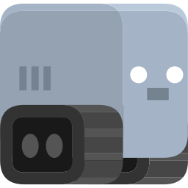

**Jump Robot**

**Thank you for purchasing the asset , if you have any question please contact me at** [**madfireongames@gmail.com**](mailto:madfireongames@gmail.com)

**Project Structure**

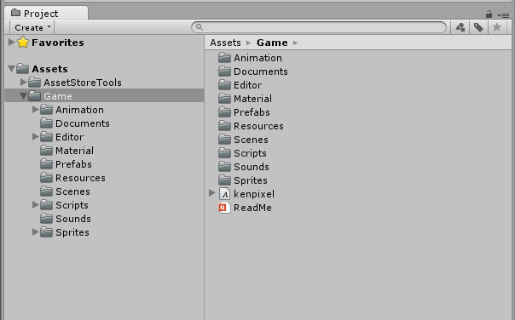

**Animations folder**: There is stored animations used in game.

**Editor Folder**: There is stored Game Design window script (Dont edit anytging in this folder).

**Fonts folder**: There is stored fonts used in GameScene.

**Sprites**: There is stored all sprites and textures used in game.

**Materials:** There is store material of GameObjects used in game.

**Prefabs Folder**: There is stored Game Objects spawned in game.

**Resources Folder**: There is stored resources for Game Design (Dont edit anytging in this folder).

**Scripts Folder**: There is stored Script files used in game.

**Sounds Folder**: There is stored Musics and Sound effects used in game.

**Scripts**

1. GameManager:- This script controls the game , its saves and loads data from the device eg:- Best Score , musics status ,etc.

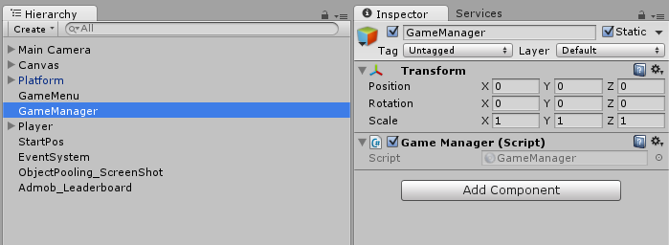

1. GameMenu:- This script controls the game menu , is assigns the functions to the buttons and updates the text like score , best score , etc;

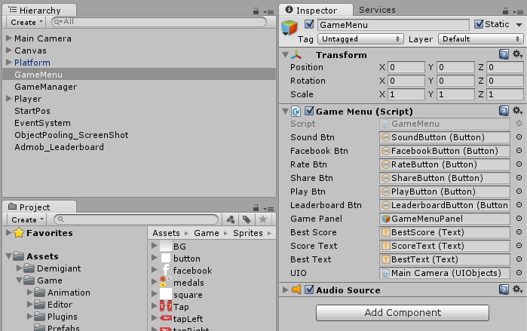

1. ObjectPooling:- This script created the required clone of objects which are used again and again and it the make them active when required , helps in game optimization.

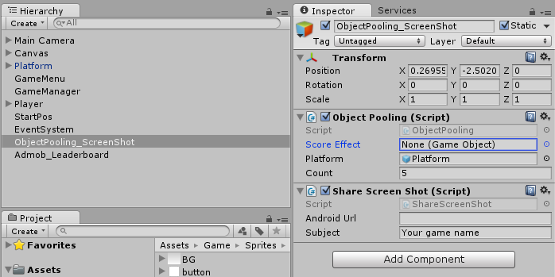

1. ScreenShot:- This script helps player to take the screen shot of their game and share it on the social platforms like facebook , whatsapp , etc.



1. UIObject:- This script keep tack of all the elements in the scene like sprites , text , sound , font etc .

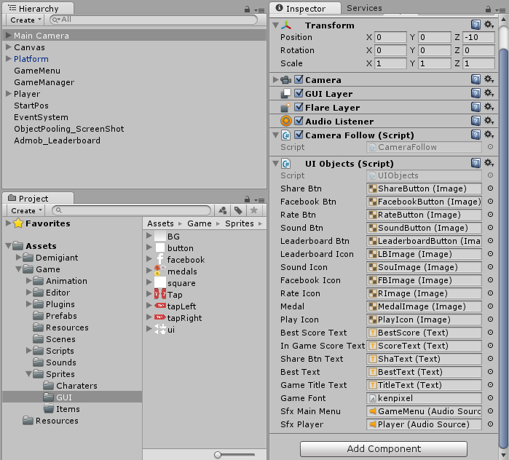

How To Reskin?

Go to Tools -> Click on GameDesign.

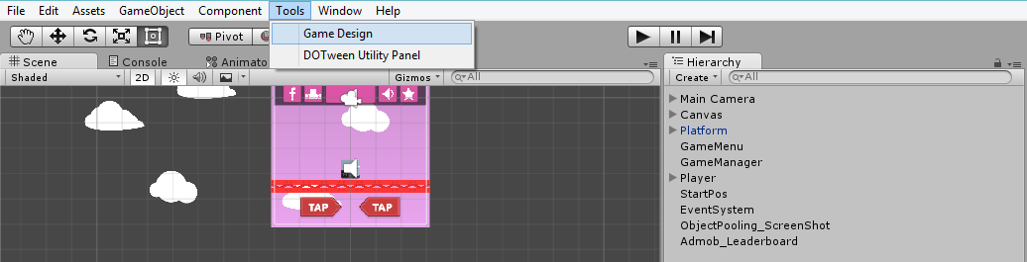

GameDesign window will open.

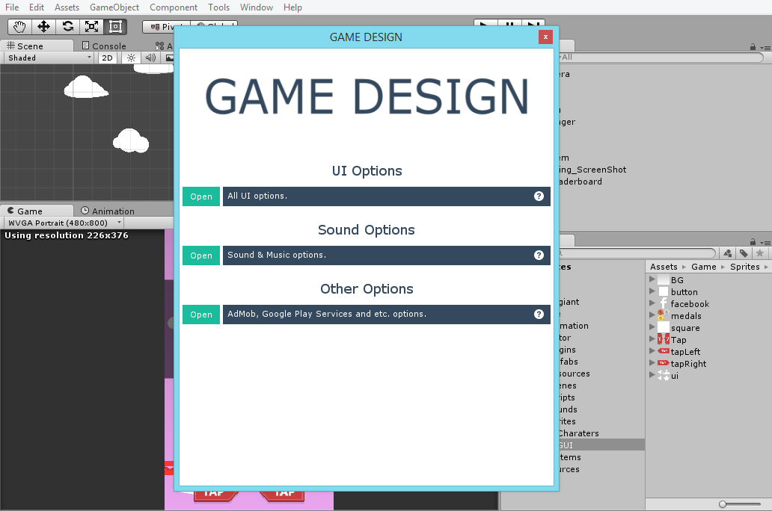

Open any section and you will find fields to change.

**Game Design: UI Options**

You can easily edit all UI Elements like Button sprites, Text colors.

All available configurations is listed bellow:

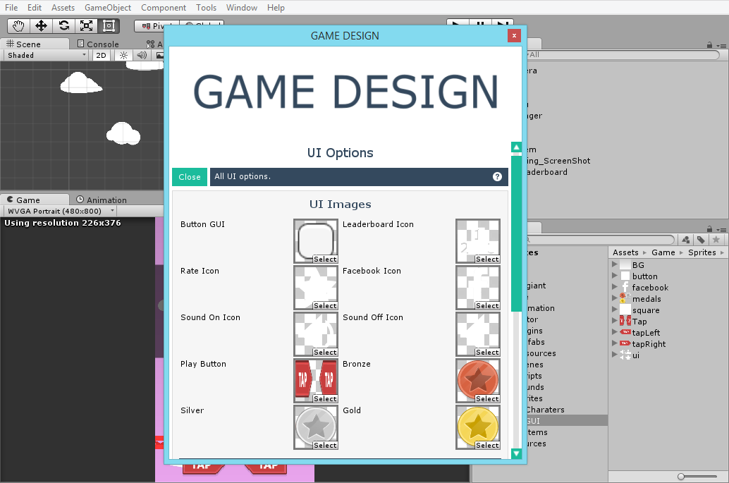

**Game Design: Sound Options / Other Options**

You can easily edit all sounds and musics like characters sound effects, buttons click , admob settings , Leaderboard for iOS and Android , and much more.

All available configurations is listed bellow:

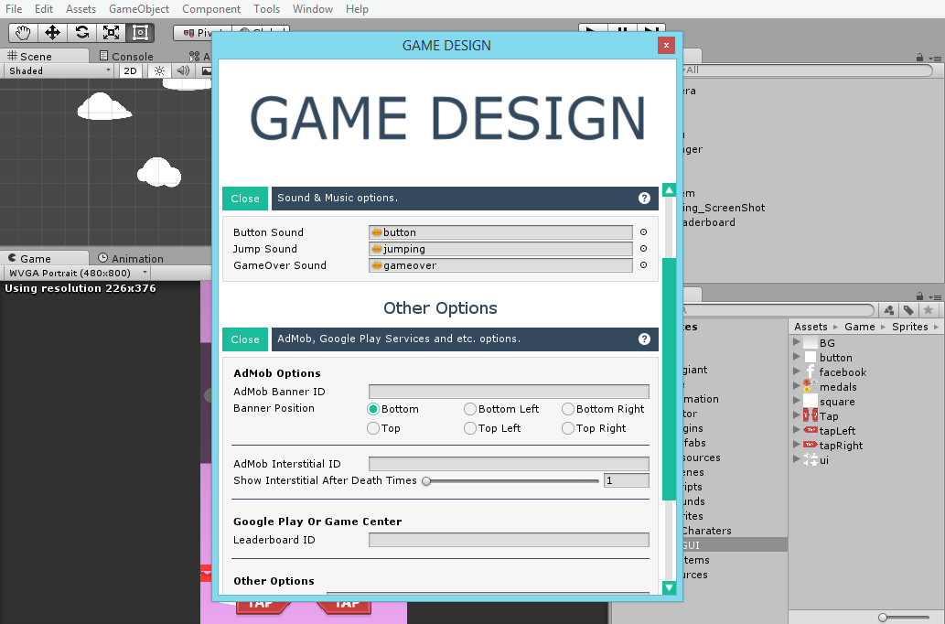

The only thing which you cannot change from here is the sprites of Player , enemies and platform , you will have to do it manually.